Flow:  
  
  
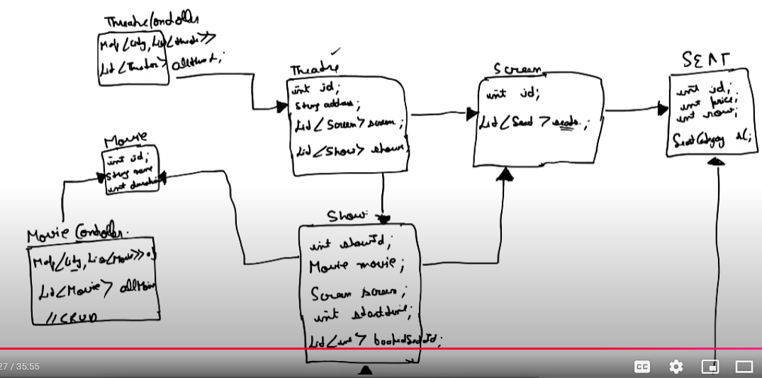

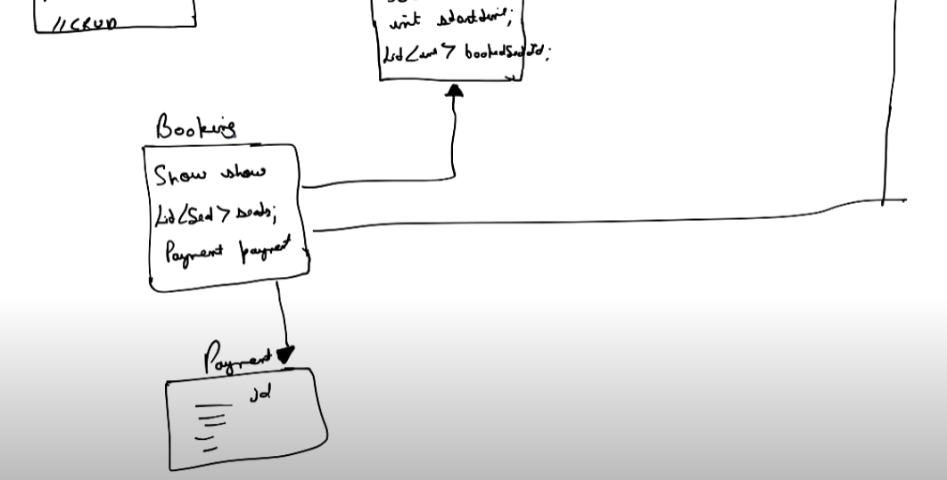

There are 2 types of locking:  
  
1. Pessimistic  
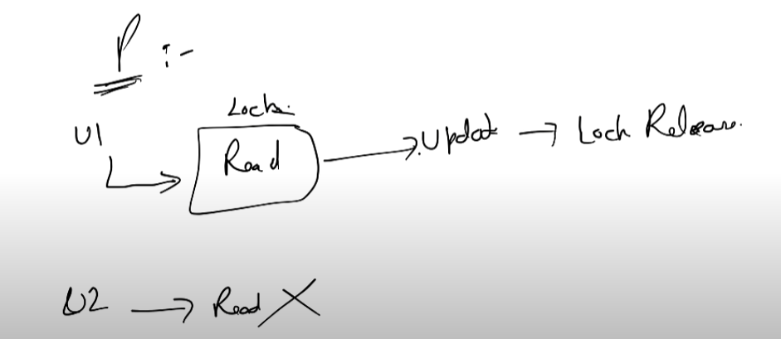  
  
First we try to read where seats are read and then as soon as we select a seat a LOCK is obtained on it. U2 fails to read as there is a lock that is acquired.  
  
  
  
2. Optimistic   
  
It allows multiple users to READ. And then during updation it checks for the version. If version has not changed it will acquire a LOCK do the update and version too is updated and then LOCK is released.  
Now if another user comes to update there will be a mismatch in version no. and this will cause the user to READ the data again.  
  
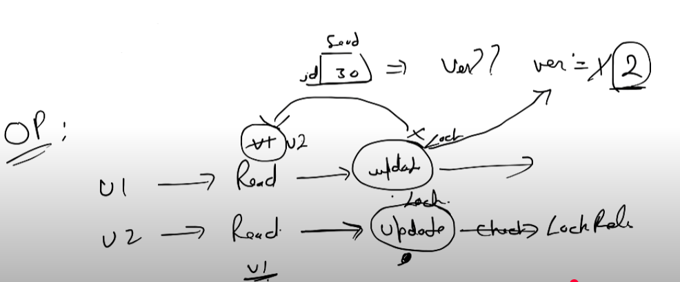  
  
  
In case of movie booking we go ahead with optimistic locking . Or else if a user keeps selecting seats in case of pessimistic locking we would be acquiring lock for a lot of seats in one go resulting to a scenario where other users will not be able to access the seats.  
  
  
Now for the scenario of expiry time to release the lock this can be done using Redis.